SERVING US IN WORSHIP TODAY
A Cup of Kindness
LITURGIST 8:15 Rev. Debby Ingram 10:30 10:30 xxxxxxxxxxxx
ORGANIST & HANDBELL DIRECTOR Cheryl Todd
CHOIR DIRECTOR Jonathan Tatar
CONTEMPORARY MUSIC Jon Conover and ReBorn
PIANIST Sue Gilla
_____________________________________________________________________
ANNOUNCEMENTS

RETURN TEAM NEWS: The church council is working hard to establish a Return to Church plan following CDC, State, and the Northern Illinois Conference guidelines. The team will be sending a survey to the congregation. Please take the time to complete the survey so that they may best asses your worship needs moving forward in a safe and spiritual manner.

CHURCH REMAINS CLOSED until further notice. From Bishop Dyck: Please “love your neighbor” and do not open for worship at this time! Thank you for your willingness to stay the course — worship with each other online or through other means until we have greater assurance that it is safe to come together again. Always check the church website and Facebook page for the most current and up to date opening information.

GIVING: Online giving is available and is appreciated as we will still have our regular operating costs and bills. Please mail in your giving to P.O. Box 695 5 W. Washington St. Oswego IL 60543 or use our E giving for online giving https://giving.ncsservices.org/app/giving/goodshepherdoswego
which can also be found on our website under the giving tab. ~ Thank you!

JOYS AND CONCERNS: Sunday morning Joys and Concerns may be submitted to the office for Pastor Steve to lift up in prayer on Sunday mornings. You may leave them on voicemail or email us. 630-554-3269 or www.goodshepherdoswego.org
If you would not like your Joy or concern mentioned publicly and or you are in need of Pastoral care, you may still leave it and ask to not be mentioned.

The Church of the Good Shepherd
United Methodist Church
Online Worship Service
June 28, 2020

Office: (630) 554-3269 Email: office@goodshepherdoswego.org

Pastor: Steve Good (630) 608-7843
pastor@goodshepherdoswego.org

Publication email: publications@goodshepherdoswego.org
www.goodshepherdoswego.org

“Open hearts. Open minds. Open doors.”

June 28, 2020

4th Sunday after Pentecost

WELCOME! We are happy you came to worship with us today. If you would like to join our mailing list please subscribe on our website. www.goodshepherdoswego.org

PRELUDE There is a Balm in Gilead Traditional Spiritual

WORSHIP IS CELEBRATING GOD’S LOVE AND POWER

CALL TO WORSHIP
Leader: Yahweh, listen to my appeal, lend an ear to my prayer, my lips free from dishonesty.
People: I have treasured the words from your lips, walking deliberately in your footsteps, so that my feet do not slip.
Leader: I call upon you and you answer me God; display your marvelous kindness!
People: For me the reward of virtue is to see your face, and, on waking, to gaze my fill on your likeness. +

SPECIAL MUSIC A Happy Man Jon Conover & Tom Hartnett

Let Go Jon Conover & Tom Hartnett

WORSHIP IS SHARING AND PRAYING

JOYS AND CONCERNS
Leader: “Lord, in your mercy”
People: “Hear our prayer”

HYMN NO. 432 Jesu, Jesu Jonathan Tatar Accompanist: Sue Gilla

PRAYER OF PRAISE AND ADORATION
O God, you hear our pleas and listen to our appeals. You watch over our nights and fill our days with your presence. You cause our feet to stand on firm places and give our eyes visions of your kindness and mercy. Hear us now as we gather to praise and adore you. Speak to us that we may learn of your ways. Amen. +

SILENT PRAYER, PASTORAL PRAYER & THE LORDS PRAYER #895

WORSHIP IS HEARING GOD’S WORD

SPECIAL MUSIC How Beautiful Bonnie McGraw
Accompanist: Sue Gilla

SCRIPTURE: Psalm 13, Matthew 10:40-42 Rev. Debby Ingram

SERMON: A Cup of Kindness Pastor Steve Good

WORSHIP IS WITNESSING TO THE WORLD

HYMN NO. 75 (vs. 1,2 & 4) All People That on Earth Do Dwell

BENEDICTION

POSTLUDE Go Forth for God by Bourgeois

+ Kirk When We Gather
Jesu, Jesu by Tom Calvin Hope Publishing 1969
How Beautiful 1990 Ariose Music (Admin. by Capitol CMG Publishing)
Mountain Spring Music (Admin. by Capitol CMG Publishing)

CCLI # 1510043, CCLI Streaming # 2015

Readings: Psalm 13

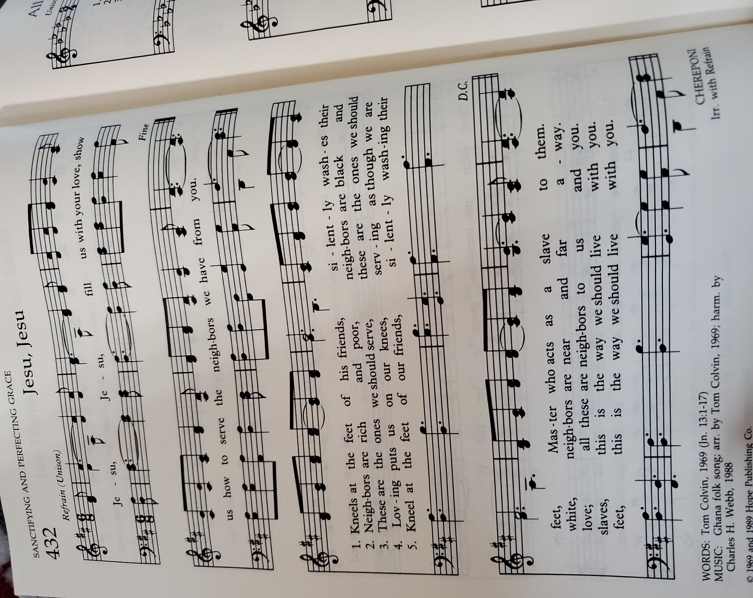
How long, O Lord? Will you forget me forever?
How long will you hide your face from me?
How long must I bear pain in my soul,
and have sorrow in my heart all day long?
How long shall my enemy be exalted over me?
Consider and answer me, O Lord my God!
Give light to my eyes, or I will sleep the sleep of death,
and my enemy will say, “I have prevailed”;
my foes will rejoice because I am shaken.
But I trusted in your steadfast love;
my heart shall rejoice in your salvation.
I will sing to the Lord,
because he has dealt bountifully with me.

Matthew 10:40-42

“Whoever welcomes you welcomes me, and whoever welcomes me welcomes the one who sent me. Whoever welcomes a prophet in the name of a prophet will receive a prophet’s reward; and whoever welcomes a righteous person in the name of a righteous person will receive the reward of the righteous; and whoever gives even a cup of cold water to one of these little ones in the name of a disciple—truly I tell you, none of these will lose their reward.”

